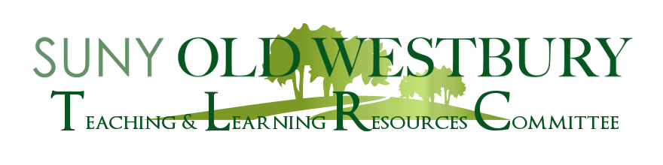

**Fostering Accessible Learning Environments**

**Navigating Accessibility in the Pandemic Classroom(s)**

A Workshop Led By

**Jillian Nissen (Biological Sciences), Kerry Weir (School of Education), and Stacey DeFelice (Office of Services for Students with Disabilities)**

**Monday, October 4 2:40 – 3:40pm Virtual (Zoom)**

In what ways might we improve accessibility for all students in the classroom? How can we increase accessibility face to face and wearing masks? How can we increase accessibility for students in the remote space? How can we expand our consideration of accessibility to include neurodiverse students? This faculty workshop will address these questions. We welcome your experiences and questions.

Zoom Registration:  <https://suny-ow-edu.zoom.us/meeting/register/tZErfuyurzMuG9dssAYJvWwhW2jWsZST7Rpl>